Experiment 32: Morphological Operations using OpenCV — Closing Technique
Software / Tools: Python · OpenCV (cv2) · NumPy

AIM
To apply the morphological Closing operation (dilation followed by erosion) to fill small holes and gaps inside foreground objects.
ALGORITHM
1. Import OpenCV and NumPy.
2. Read the input image, convert to grayscale, and threshold it to get a binary image.
3. Define a structuring element (kernel).
4. Apply cv2.morphologyEx() with the flag cv2.MORPH_CLOSE.
5. Display and save the closed result.
PROGRAM (SOURCE CODE)
import cv2
import numpy as np

img = cv2.imread("image.jpg")
gray = cv2.cvtColor(img, cv2.COLOR_BGR2GRAY)
_, binary = cv2.threshold(gray, 120, 255, cv2.THRESH_BINARY)

kernel = np.ones((5, 5), np.uint8)
closing = cv2.morphologyEx(binary, cv2.MORPH_CLOSE, kernel)

cv2.imshow("Closing", closing)
cv2.waitKey(0)
cv2.destroyAllWindows()

OUTPUT
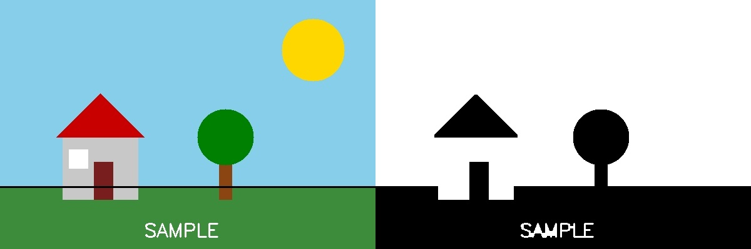
Fig. 32 — Output of Experiment 32: Morphological Operations using OpenCV — Closing Technique.
RESULT
Apply the morphological Closing operation (dilation followed by erosion) to fill small holes and gaps inside foreground objects — completed successfully, as demonstrated in the output shown above.

